After a user has authorized the application, the authorization can be removed. This can be useful for testing the authorization process.

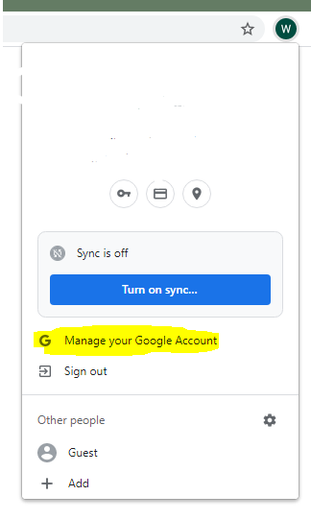

Machine generated alternative text:
Google Account 
Q 
Search Google Account 
Onal info 
Data & personalization 
Security 
People & sharing 
O 
Payments & sc 
Third-party apps with account access 
You gave these sites and apps access to some of your Google Account data, including info 
that may be sensitive. Remove access for those you no longer trust or use. 
Appointments Test 
Manage third-party access 
Has access to Google Calendar 